Alexa Valeria Enamorado Ayala
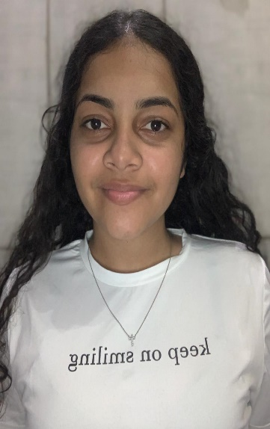 | Identity Number: 0101-2002- 00197  Date of Birth: 18 de Diciembre del 2001  Address: La Ceiba ,Atlántida Honduras  Age:21años  Civil Status: Soltera  Nationality: Honduran  Email Address: alexavenamorado01@gmail.com  Phone Number: +504 3221-9514  O B J E C T I V E  To be part of a work team and consolidate myself professionally in a company where personal achievements are recognized, in addition to allowing opportunities for personal and professional development.

academic course

Brassavola Bilingual School
Diploma in Bachelor of Science and Humanities

languages

Spanish 100%
English 100%

Skills

- Creativity
- Kindness
- Teamwork
- Skill in Customer Service

W O R K E X P E R I N C E

Caribbean Contact Center – customer service
Alorica Honduras – experience customer service and sell

reference

Viany Nohemi Lopez Meza
Supervisor Carribean Contact Center
+504 3203 9374

Jamila M. Díaz

Enlace Avanza-Fhi360-VOEA UNAH TELA
9721-4676
Jamila.mdiaz@hotmail.com

